2020 Words of the Week - Cold War #1

Monday: Match the word to the correct definition below.
- Marshall Plan  A plan in which the United States gave economic aid to countries reduce the appeal of Communism | Cold War  A war in which the two Superpowers never confronted each other directly in open warfare due to the threat of nuclear weapons | Communism  - A way of organizing a society in which the government owns the things that are used to make and transport products (such as land, oil, factories, ships, etc.) and there is no privately owned property | Containment Policy  A policy in which they did not attempt to overturn communism where it already existed but they resolved to prevent it from spreading further
Truman Doctrine Sought to help Greece and Turkey; doctrine promised U.S. assistance to all free peoples resisting Communism | North Atlantic Treaty Organization (NATO)  Alliance of United States, Canada, & Western Europe; members pledged a common defense against aggression | Berlin Airlift  -Soviets blockaded Berlin; United States sent in supplies until the Soviet blockade ends | Iron Curtain  - The Soviets cut-off trade and contact between Eastern Europe & Western Europe

Tuesday: Capture It! Create a picture to represent each word.
Cold War  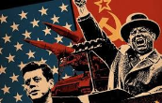 | Communism  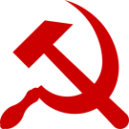 | Iron Curtain  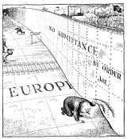 | Truman Doctrine  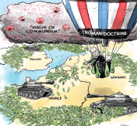
Marshall Plan  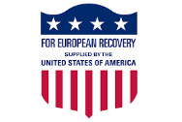 | Berlin Airlift  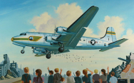 | Containment Policy  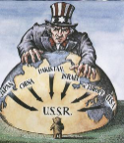 | NATO  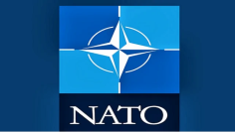

Wednesday: 3 Clues: 1 word: Use clues to identify the words of the week.
Iron Curtain  -Soviets  -Trade/Contact  -East/West | Communism  -Government  -Ownership  -No private property | Cold War  -War  -Superpowers  -Nuclear weapons | Berlin Airlift  -Berlin  -Blockade  -Supplies
Marshall Plan Economic  -Aide  -No communism | NATO  -Alliance  -Common Defense  -Western Europe | Truman Doctrine -Doctrine  -Greece/Turkey  -Resist | Containment Policy  -Communism  -Contain  -Not Spread

Thursday: Answer the questions

Immediately after World War II, the relationship between the United States and the Soviet Union was strained because -
- The United States used military force in Korea
- The United States blocked the Soviet Union from joining the United Nations
- Each country believed that the other one was a threat to its security
- Both countries were competing for supremacy in space exploration

The Truman Doctrine was originally designed to -
- Stop the use of nuclear weapons
- Contain Communism by giving aid to Greece and Turkey
- Used the United Nations as a tool to eliminate threats posed by the Soviets
- Rebuild Korea by extending economic aide

Friday: Answer the questions in complete sentences.

- Why did the United States and the Soviet Union enter into the Cold War?
The core reason behind the colds war between the United States and the Soviet Union was the ideological differences held by the parties. The United stated believed in multi-party democracy and greatly resented the communist ideology by the Soviet Union because they saw it as threat to security, political stability and world freedom.

- What was the purpose of the Marshall Plan?
The Marshall Plan was a plan by the United States aimed at reducing the appeal of communism in post war Europe by providing economic aid to countries.

1. Roots of the cold war
  - There major differences between the United States and Soviet union were ideological. The Soviet union held communist believe while The united states held multi-party democratic views and the desire to spread these ideologies led to the cold war
  - The Iron Curtain was a separation and cut off of trade and other economic between the Eastern and Western Europe due to ideological differences.
  - The Berlin airlift was necessitated, by the blockage of Berlin by USSR preventing the entry of supplies the US airlifted supplies to help them
- Attempts At Containment
  - The Truman Doctrine was a pledge for economic and military support to Turkey and Greece by the US to prevent them from falling for communism ideologies forced on them by the USSR.
  - The Marshall Plan was a success because it greatly helped Western Europe recover after World War 2.
  - The creation of NATO and Warsaw Pact was significant in that it help prevent the spread of both communist and democratic ideologies by pledging military allegiance by mender countries.
  - Korean war
- The Korean war was caused by the conflicting US and USSR on their support on North and South Korea to prevent the spread of communist ideologies after USA lost china to communist ideologies.
- The United States was involved because it feared that the USSR would forcefully impose communism on Korea and that would be detrimental in their efforts to compact its spread.
- An armistice signed in 1953 between the USA under Dwight D. Eisenhowe and North Korea ended the Korean war by demilitarizing the area.
4. Arms & Space Race
- This was race started when the united States monopoly to produce nuclear weapons ended and USSR developed and tested an atomic bomb. The two countries continued to build nuclear weapons until they both had weapons that could destroy them
- The Arms race led to the development of large nuclear equipment that had power to destroy the world massively.
- The Sputnik led to heightened cold war as the USSR and the USA struggled to proves space dominance.

- 4. Arms & Space Race
- This was race started when the united States monopoly to produce nuclear weapons ended and USSR developed and tested an atomic bomb. The two countries continued to build nuclear weapons until they both had weapons that could destroy them
- The Arms race led to the development of large nuclear equipment that had power to destroy the world massively.
- The Sputnik led to heightened cold war as the USSR and the USA struggled to prove space dominance.

5. American Security
- The House Un-American Activities Committee was significant in identification of any possible the subversion of the American government by the communists by investigating important government officials and writers and then blacklisting communist sympathizers.
- The Rosenberg Trials and Venona Papers revealed the identity of American persons spying the country’s science and industry during the period of the cold way for USSR.
- “McCarthyism” is the act of making accusations without and substantial evidence to back the.

VIP Notes: Cold War VIP
The Cold War is a period of heightened tension between the superpowers in which there is a “ war of words” & threats of nuclear war.  - Problems between U.S. and Soviet Union come out of their ideological differences  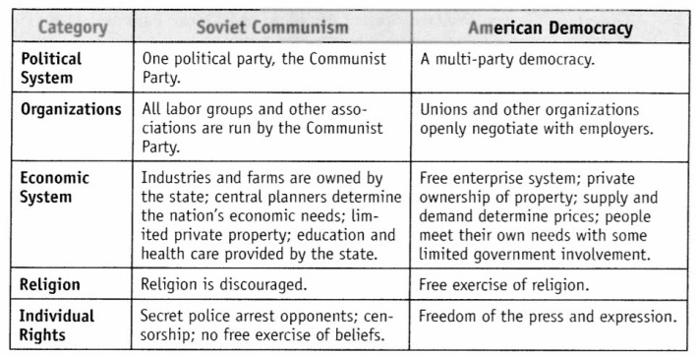 | What is a Cold War?  The Cold War is a period of heightened tension between the superpowers in which there is a “ war of words” & threats of nuclear war.  What do you think is the most significant difference between the United States and the Soviet Union? There existed ideological, political economical and religious.
Roots of the Cold War  - Soviet Occupation  - Stalin, the leader of the Soviet Union, wants to create a buffer between the Soviet Union and Western Europe  - Stalin used his military to install communist governments in Eastern European nations  - Eastern European nations turned communist and became Soviet satellites: nations that were influenced by the Soviet Union.  - Iron Curtain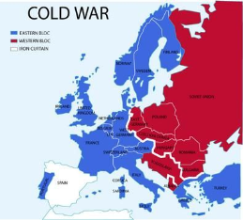  - By 1946, Europe was divided by an “iron curtain” that separated democratic/capitalist Western Europe from communist/totalitarian Eastern Europe.  - Berlin Airlift  - The Soviet Union cut off supplies routes into Berlin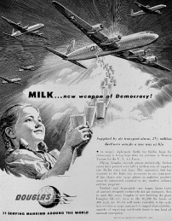  - The United States and Great Britain used airplanes to drop food, fuel & needed supplies into West Berlin.  - Successfully kept West Berlin from being communist | Who was the leader of the Soviet Union?  Stalin was the Soviet Union leader.  Why did Stalin use his military to create communist governments in Eastern Europe?  Stalin used military to spread ccommunist ideologies and rule.  Why do you think the Berlin Airlift was successful in fighting communism?  Yes, the Berlin Airlift was a successful tactic to fight communism because it helped teh US to stop the imposition of communism on Berlin by the USSR.
Attempts at Containment  - Containment -  - United States foreign policy  - Keep Communism from spreading to other parts of Europe &  the world.  -Truman Doctrine  - Promised economic & military help to any nation threatened by communism  - Gave 400 million dollars of aid to Greece & Turkey  -Marshall Plan  - Helped struggling European nations recover from WWII  - Feared these countries would turn to communism  - Offered $13 billion to help rebuild post-war Europe  -NATO, 1949  - United States formed the North Atlantic Treaty Organization  (NATO)  -A military alliance among democratic countries in Europe &  North America.  - Warsaw Pact  -Soviet Union's answer to NATO  -Soviet Union and Eastern European nations  -Unified military under the control of the Soviet Union | Why would the United States want to contain communism?  The United States wanted to contain the spread of communism because they saw it as a threat to their security and world freedom.  The Truman Doctrine and the Marshall Plan prevented the spread of communism in that it helped subvert any efforts by USSR to impose communism on them since they already had financial support to recover after the War.  The NATO and the Warsaw Pact were formed by the US and USSR allies respectively to pledge allegiance and military support in the event of a physical
Korean War  - Domino Theory - United States believed that communist countries would turn neighboring countries communist  - June 1950, North Korea (Soviet Support) invades South Korea (U.S. support)  - United Nations sends in a peacekeeping operation  - Led by General Douglas MacArthur  - Push back North Koreans but when get close to China; China enters the conflict to help North Korea  - MacArthur wants to invade China & use atomic bombs to free it from Communism; removed from command after questioning President Truman  - Armistice is signed in 1953 ending the fighting & separating North & South Korea with a demilitarized zone (area no weapons/armies) | What is the domino theory? This was a theory by the United states that stipulated that the communists would spread their ideologies to their neighbours.  Why was MacArthur removed from his command? He questioned President Truman.  What is a demilitarized zone?  The demilitarized zone was a zone of no weapon or armies created when the amristice was signed to end the korean war.
Arms Race  - Threat of Nuclear War was most frightening part of Cold War  - 1949, Soviet Union has atomic bombs  - President Eisenhower escalated the Cold War by threatening to use nuclear weapons  - Both countries began stockpiling nuclear weapons & building up their militaries  - USA & Soviet Union developed rockets called intercontinental ballistic missiles (ICBMs)  - Each side could destroy each other: this was known as Mutually Assured Destruction (MAD).  Space Race  - Soviet Union launched first satellite into orbit, Sputnik  - US forms NASA to catch up to Soviet Union  - Soviet Union repeatedly beats the US in space & launches the first man into orbit  - 1962, President Kennedy commits to putting a man on the moon and the first astronauts set foot on the moon in 1969 | Why did the United States continue to create more nuclear weapons?  The US continued to create more nuclear weapons in fear of USSRs’ nuclear wepons creations.  What is Mutually Assured Destruction?  The fact that nothe the US and The Soviet Union had created nuclear weapons that could destroy each other.  What was important about Sputnik? The orchestrated the start of space ars between the US and the soviet union leading to creation of more space exploration equipment.
American Security  - House Committee on UnAmerican Activities  - Investigated Communist subversion in government  - Questioned actors, directors, writers, and others  - Identified as members of the Communist Party were "blacklisted" and lost their jobs.  - Those who cooperated with the committee were often asked to give information on other people  - Ronsenburg Trials  - Julius and Ethel Rosenberg were charged with being Soviet spies for selling national secrets on the building of the atomic bomb  - The Rosenbergs were found guilty and executed for spying  - Many Americans doubted their guilt but with the release of the Venona papers Julius Rosenberg was proven to be a spy  - Senator Joseph McCarthy  - Launched an anti-communist campaign; claiming that he knew the names of hundreds of Communists that had infiltrated the United States government.  - Created fears of a Communist conspiracy to take over the United States.  - After three years of hearings, McCarthy never provided real proof of the charges  - "McCarthyism" is now used to describe people making accusations without evidence.  - McCarthy was formally censured (formally criticized) by the Senate | Why were Americans scared for their safety?  Marican feared for tier safety because they thought that communism was a threat and could be spread by the USSR to its neighbours.  Why were the Rosenbergs executed?#They were charged with spying on the government and selling its secrets to ist enemy the Soviet Union.  Why was Joseph McCarthy important?  He created the current McCarthyism which is the accusation of people without proof of the claims.
Summary: Summarize the important information about the early part of the Cold War. Your summary must be written in at least 3 complete sentences.
The Cold war was due to differences in ideologies between the US and the Soviet Union. The United states used several strategies to contain the spread of communism that include the Truman doctrine, Berlin Airlift and the MArshall plan. The differences between Us and the Societ union and the desire by each to control Korea ed to ets start of the Korean war. Lastly the Cold war is characterized by arms and space races between the Us and the USSR.

